AMYLASE ACTIVITY ASSIGNMENT

EXERCISE 4B

BACKGROUND: For full background information, read exercise 4B in your lab manual. Also, watch the two videos on Bb to help you understand this exercise. The links for the videos are here:

https://expl.ai/UNXQNFB https://expl.ai/PDYGPLU

Chemical reactions that take place in the cell do not occur randomly, they are controlled by biological catalysts, called enzymes. A catalyst is a substance that speeds up the rate of a chemical reaction without being used up by the reaction. Enzymes speed up the rate of a reaction by lowering the initial amount of energy required, called the activation energy (EA). Activation energy is required by all chemical reactions to break certain bonds (free up electrons) in the reactant(s) so that new bonds can form, resulting in product formation. Enzymes use energy from the surrounding environment to increase molecular movement and cross the activation energy barrier to start a reaction but do not provide energy.

Most enzymes are proteins whose primary structure is dictated by genes.
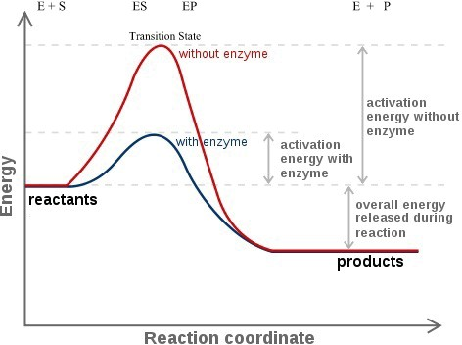

Enzymes do not become active until the polypeptide chains are folded into a unique 3 dimensional (3D) shape. The 3D structures are held together by various non-covalent interactions such as hydrogen bonds, ionic bonds, disulfide bridges, hydrophobic and Van der Waals interactions. It is vital for
proteins to maintain their unique 3D shape in their respective environment.

Thousands of product molecules may be formed in one second by an individual enzyme. Reactants in an enzymatic reaction are called substrates and substrate(s) bind to the enzyme at a specific site, called the active site.

Like all proteins, enzyme activity is affected by environmental conditions. Factors like temperature, pH, and salt concentration interfere with the non-covalent forces that give enzymes their 3D shape and enzymes then start to unfold, or denature. Alpha helices and beta sheets, for example, are disrupted in denaturing conditions, and the peptide chain takes on a random shape. Denaturation does not break peptide bonds, so the enzyme’s primary structure is unaffected. However, because the enzyme has changed shape, the active site is also altered and will not complement and bind the substrate as well. The reaction rate therefore decreases accordingly. Enzymes can structurally be similar, and catalyze the same reaction, yet they may have important differences leading to different optimal temperatures.

To learn about the function and structure of enzymes, we will be using the enzyme amylase as a model in this lab. Alpha amylase, is an enzyme that catalyzes the breakdown (hydrolysis) of α-1,4 glycosidic linkages of starch (a polymer of glucose), into maltose (a reducing disaccharide made of two glucose molecules). Because starch is one the most abundant carbohydrate polymers on earth, it serves as a major source of energy not only for us but for many other animals, higher plants and microorganisms as well. In order to harvest the energy from starch, the enzyme amylase, present in the saliva and pancreatic secretion of humans and other mammals, begin the chemical process of breaking (or hydrolyzing) it down into smaller sugars. The enzyme, amylase, is present in all 3 domains of life, e.g., plants, animals, microorganisms such as bacteria and fungi, and all have the same catalytic function.

Starch + water Maltose
amylase

Alpha amylases from three different sources, e.g., (i) bacteria (Geobacillus stearothermophilus), (ii) fungi (Aspergillus oryzae), and (iii) human (Homo sapiens), will be used in this lab. Research the literature for information on the optimal conditions for activity of these enzymes. You will be asked to write a hypothesis and will be given data to analyze and determine whether they support your hypothesis.

Concentration of maltose can be measured using a colorimetric assay: that is, combining maltose with a certain reagent that causes a color change. The reagent in this assay is DNS (3,5-dinitrosalicylic acid) which is yellow in color. First introduced to detect reducing substances in urine, DNS assay is commonly used to quantitate carbohydrate levels in blood as well as detecting alpha amylase activity.

In an alkaline solution, reducing sugars form aldehyde or ketone groups which can then reduce different reagents (e.g., Benedicts reagent, dinitrosalicylic acid or DNS). Unlike Benedicts test for detecting the presence of reducing sugars, reaction between DNS and a reducing sugar results in a soluble and colored product. Maltose participates in an oxidation-reduction reaction with DNS due to the presence of a carbonyl group (C=O). DNS is reduced into 3-amino, 5-nitrosalicylic acid (can be referred to simply as reduced DNS) and maltose gets oxidized and becomes maltonic acid.

Maltose
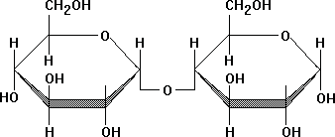

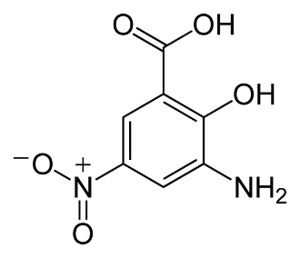
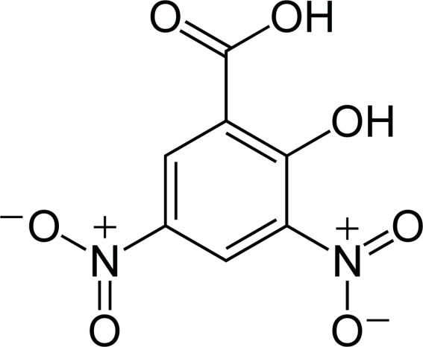

Maltose
(reduced)
Maltonic Acid
(oxidised)
Heat & Alkaline condition

Dinitrosalicylic acid
DNS (Yellow)
3-Amino-5-nitrosalicylic acid
Reduced DNS (Orange to Red)

This reaction causes a change in color from yellow to orange/red due to the presence of reduced DNS. The change in color results in a change in absorption of light, and absorbance is measured in a spectrophotometer at a wavelength of 540 nm. The intensity of color from the reaction is proportional to the concentration of maltose and is used to estimate concentration of maltose in any given solution.

The concentration of maltose produced by hydrolysis of starch is directly dependent on the activity of the enzyme, amylase. Therefore, absorbance can be used to determine the optimal conditions for amylase activity, i.e., condition(s) at which enzymes have the highest activity (Optimal condition).

ASSIGNMENT

Part A: Maltose Standard Curve:
In this part of the lab, DNS is added to known amounts of maltose, and the absorbance of the reduced DNS is measured at 540nm. A reference graph, called a standard curve, is made from this data. A standard curve is a graph which shows a relationship between two quantities, e.g., known concentrations of maltose and their absorbance. The amount of maltose produced by amylase in the experiment in the next part can be estimated if the absorbance of these tubes is read on the standard curve is matched to the corresponding maltose.

Please watch this video https://expl.ai/UNXQNFB to understand what the amylase reaction is, how to prepare the maltose standard curve, and how to graph it.

To prepare the standard curve, the concentration of maltose (mg/ml) for each tube has to be determined first. The calculations are explained on pp. 155-156 in your lab manual as well as in the video above.

- Show your calculations below and complete the final concentration of maltose in the table after using the formula C₁V₁ = C₂V₂

Volume of 2.5 mg/ml Maltose stock (μl) | Final Maltose Concentration (mg/ml) | Absorbance at 540nm
0 |  | 0.000
200 |  | 0.228
400 |  | 0.487
600 |  | 0.751
800 |  | 1.031
1000 |  | 1.275

- Graph the Absorbance vs. Concentration (mg/ml) of maltose in Excel using TAILS and insert your graph below.
  - Draw a ‘line of best fit’ through your data points by clicking on a point and selecting “add trendline”
  - In the menu that opens, select “display equation of line: the equation of the line of best fit will be now on your graph. You will use this equation later to determine the maltose produced in your experiment.

Part B: Test your hypothesis

Before doing this part, watch this video https://expl.ai/PDYGPLU on testing your hypothesis on amylase activity.

Then write a question, a hypothesis and a prediction after determining which amylase and which independent variable you were assigned.

Remember:

- Question: Remember that asking question is an important part of scientific process. The more specific questions you ask, the easier it will be for you to design experiments to test your hypothesis.

- Hypothesis: Tentative answer to the question you asked in the previous step. Write a simple but specific statement and be sure that is testable and falsifiable.

- Prediction: The prediction describes what will happen if a hypothesis is correct. Generate a reasonable prediction by completing this statement: If _____ then ____.

Determine which amylase and which independent variable you are supposed to study, based on your last name:

LAST INITIAL | AMYLASE | INDEPENDENT VARIABLE
A-B | Geobacillus Stearothermophilus  (bacterial) | Temperature
C-G | Aspergillus oryzae (fungal) | pH
H-M | Homo sapiens (human) | pH
N-R | Geobacillus Stearothermophilus  (bacterial) | pH
S-V | Aspergillus oryzae (fungal) | Temperature
W-Z | Homo sapiens | Temperature
- Write a question, a hypothesis and a prediction and define your independent and dependent variables. To write a good hypothesis, research your amylase and the organism it comes from and find out what the literature says about the ideal pH or temperature this organism is found in. Cite the source you used.

From the tables in the Appendix, choose the one that contains data for your amylase enzyme and your independent variable, according to the determination you made based on your last name. Insert your table here and delete the Appendix from your assignment.

- Using the equation of the line of best fit from your standard curve in Part A
  - Determine the maltose produced in your experiment and fill the data in your table. Show an example calculation below.
  - Determine the amylase activity in each tube and fill in that data in your table. Show an example calculation below.

- Graph the resulting Amylase Activity data vs. your Independent Variable (Excel) and insert your graph below.

- Conclusion: restate your hypothesis and summarize your results based on your graph of the Amylase Activity vs. your Independent variable. Explain whether your graph supports your hypothesis, by using information from the graph. Comment on other findings from the graph. Comment on what you think happened to the Amylase enzyme and its structure and function at points where you observe low activity.

APPENDIX

- Data from the study of the Effect of Temperature on Human Amylase Activity
Temperature ( ⁰C) | Absorbance at 540nm | Maltose produced (mg/ml) | Amylase Activity (mg/ml/min)
0 | 0.107
25 | 0.568
37 | 0.874
45 | 0.342
65 | 0.031
85 | 0.008

- Data from the Study of the Effect of pH on Human Amylase Activity
pH | Absorbance at 540nm | Maltose produced (mg/ml) | Amylase Activity (mg/ml/min)
1 | 0.029
3 | 0.103
5 | 0.267
7 | 0.945
9 | 0.112
12 | 0.015

- Data from the study of the Effect of Temperature on Fungal Amylase Activity
Temperature ( ⁰C) | Absorbance at 540nm | Maltose produced (mg/ml) | Amylase Activity (mg/ml/min)
0 | 0.129
25 | 0.246
37 | 0.539
45 | 0.839
65 | 0.137
85 | 0.024

- Data from the Study of the Effect of pH on Fungal Amylase Activity
pH | Absorbance at 540nm | Maltose produced (mg/ml) | Amylase Activity (mg/ml/min)
1 | 0.119
3 | 0.231
5 | 0.945
7 | 0.367
9 | 0.091
12 | 0.016

- Data from the study of the Effect of Temperature on Bacterial Amylase Activity
Temperature ( ⁰C) | Absorbance at 540nm | Maltose produced (mg/ml) | Amylase Activity (mg/ml/min)
0 | 0.116
25 | 0.237
37 | 0.309
45 | 0.391
65 | 0.895
85 | 1.029

- Data from the Study of the Effect of pH on Bacterial Amylase Activity
pH | Absorbance at 540nm | Maltose produced (mg/ml) | Amylase Activity (mg/ml/min)
1 | 0.995
3 | 0.637
5 | 0.209
7 | 0.107
9 | 0.048
12 | 0.037

